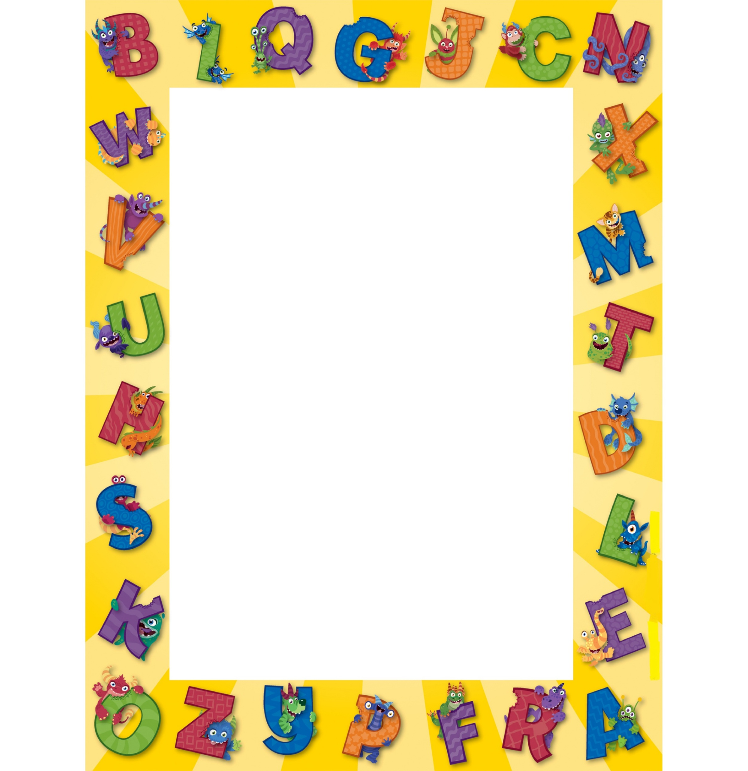
Figure 1

D.A.V.PUBLIC SCHOOL
Pakhowal Road, Ludhiana
(Affiliated to CBSE,New Delhi, Affiliation Code No. 1630459)
E-mail: davpakhowal@gmail.com Phone: 91-161-2807075

Dear Parents
Namaskar !
Welcome to D.A.V., Pakhowal Road , an educational institution with a vision to provide a stimulating and harmonious learning environment which maximizes the innate potential of the students and ensures their all round development. We feel honoured that you have chosen this institution for the education of your ward and we look forward to work with commitment towards you and your child. Parents are requested to note down the following points for the upcoming academic session –
- New academic session for Pre – KG commences on: 7th April, 2016 (Thursday).

- For 7th April to 9thApril 2016, school timings for Pre – KG will be 10am to 12 noon. For these days, parents are requested to drop their wards themselves and pick them after two hours from the respective classrooms.

- From 11th April 2016 Timings : 9am to 12:50 pm.Pre- KG students will come and go by school transport.

- Kindly get the I –Card of your ward photocopied ( at least 5 copies ) and laminated for future use .

- Name, Class & Section of your ward should be written on every belonging of the child. Keep extra clothing, apron and a small tumbler in bag. Do not send water bottles.

- Please give nutritious food to your ward. Tiffin should be packed with vegetable and parantha in a cloth napkin. Avoid the use of aluminium foils for wrapping chappati. Clean the bag regularly.

- Incase your child forgets to bring the lunch, the lunch box will not be accepted at the school reception.

- Children belonging to affluent families and coming by luxury cars become easy targets of criminal minded people. Parents are requested to send their wards in school transport only. In case of private conveyance, the driver must be introduced to the security guard of the school and the class teacher.

- In case your ward does not reach home in time, do not get panicked. such children back to school and they are sent in the second trip
- On the birthday of your ward, please send good quality bakery biscuits only to distribute in the class. We do not allow distribution of costly gift packs etc
- School is closed on every second Satutday

\ Summer uniform for Pre – KG to UKG Students

Your suggestions and feedback for the improvement of the school are always welcome.
With regards

Mrs. Sangeeta Mohindroo Dr. Mohan Lal Sharma
Academic Supervisor Principal

Boys: Fawn shirt (half sleeves), Check shorts
Fawn socks with stripes., Brown Liberty Force 10 shoes, Fawn patka .
Girls: Fawn shirt (half sleeves), Check skirt
Fawn socks with stripes., Brown Liberty Force 10 shoes, Fawn ribbons

Monday – Friday Saturday

Pre –KG to UKG 9:00 a.m. to 12:50 p.m. LKG &UKG 9:00 a.m. to 12:10 p.m.
I & II 8:00 a.m. to 12:50 p.m. I & II 8:00 a.m. to 12:10 p.m.
III to XII 8:00 a.m. to 02:10 p.m. III to XII 8:00 a.m. to 01:30 p.m.

